HDMI Switcher

Quick Start Guide
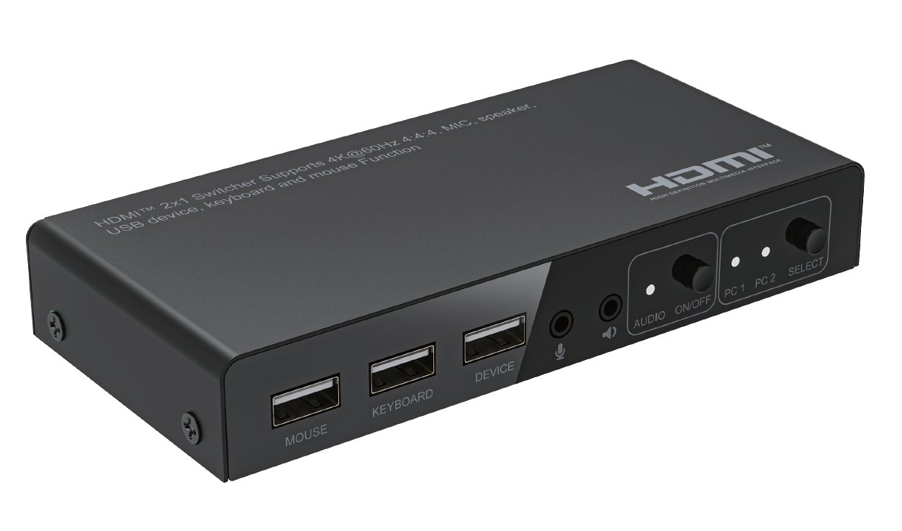

What’s included
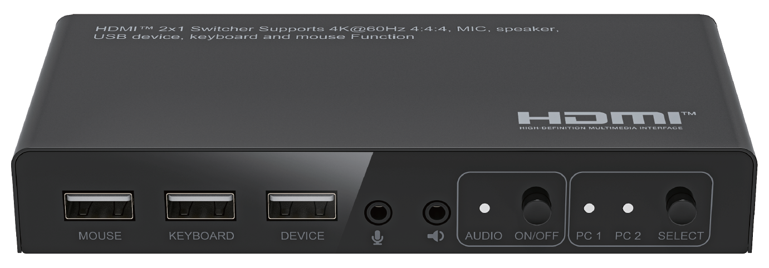
Main Unit
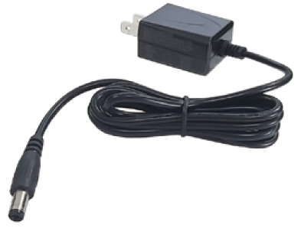
Power Adapter x1

Ports and Interfaces

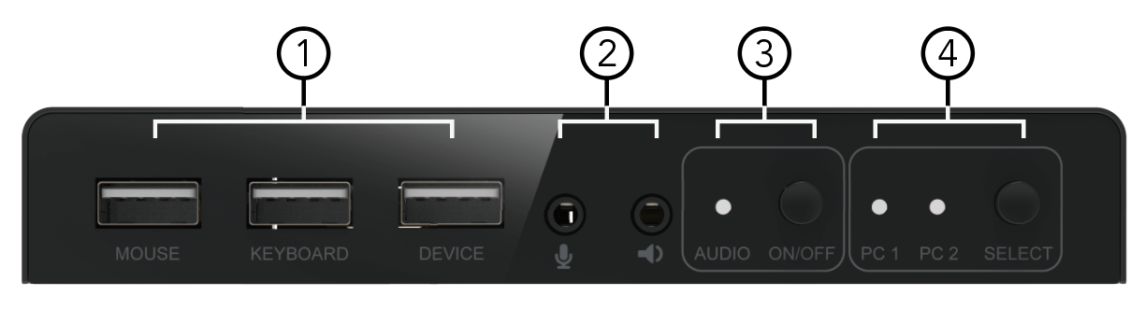
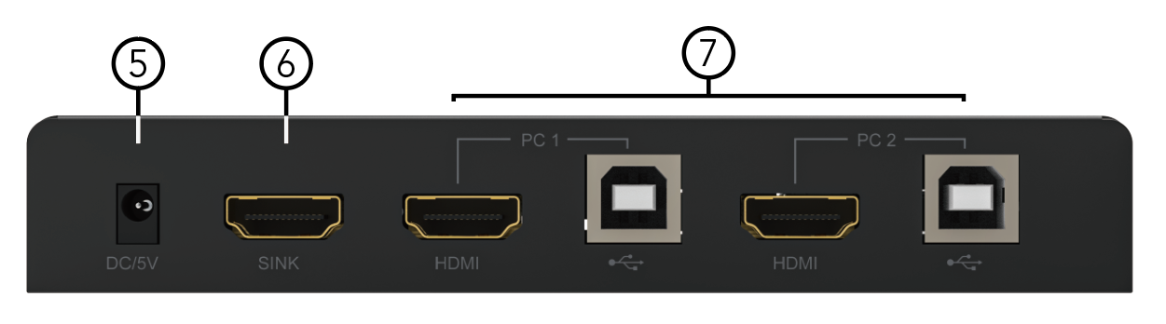

1. MOUSE: Connect to the mouse device port
KEYBOARD: Connect to the keyboard device port
DEVICE: Connect to the U-disk device port
2. MIC: Mic audio in port
AUDIO: Stereo audio out port
3. AUDIO and ON/OFF: Turn on/off the audio function button and indicator
4. SELECT and PC1-2: SELECT Button and PC1-2 port indicator
5. DC/5V: DC 5V IN port
6. SINK: HDMI Output Port to connect the displays
7. HDMI and USB-B Port of PC1-2: HDMI in and USB-B Port of PC1-2 to connect the PC in

Connection Diagram
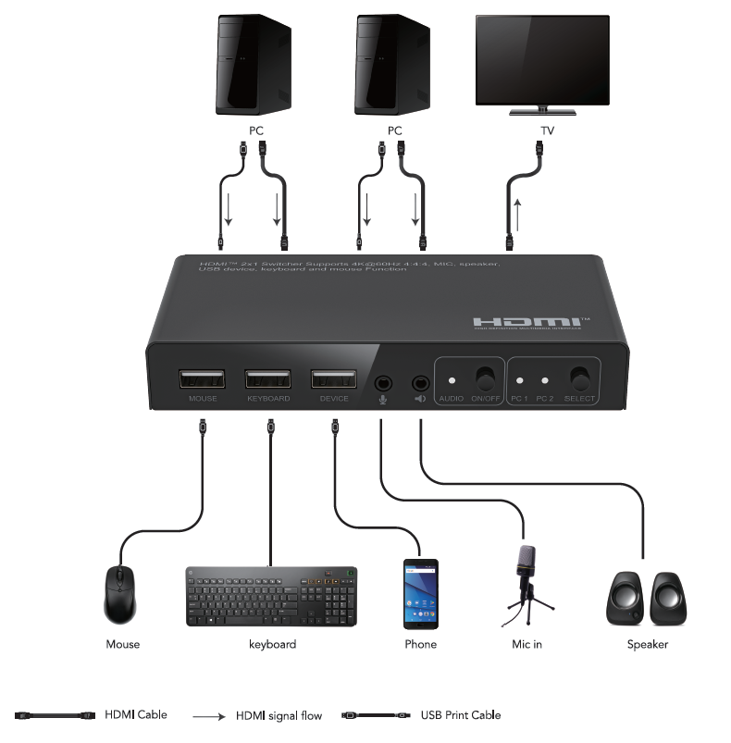Hotkey Switching Command
Follow the hotkey command list below for selected operating functions:
Command | Function
Right CTRL + Right CTRL + n, n=1,2,3,4 | switch to the PC1-4 input
Right CTRL + Right CTRL + s | Turn on/off automatic scanning, 10 seconds for default scanning
Right CTRL + Right CTRL + b | Switch on/off the buzzer
Right CTRL + Right CTRL + t | Switch on/off the automatic detection function
Right CTRL + Right CTRL + r | Reboot the device and reset the input port
Right CTRL + Right CTRL + s + n | Setting the automatic scanning time from 8 to 999 seconds
Right CTRL + Right CTRL + Scroll lock | Switch Scroll lock to hotkey, Scroll lock + Scroll lock + Right CTRL + Enter, change the hotkey from Scroll lock to Right CTRL(default)
Right CTRL + Right CTRL + Num lock | switch Num to hotkey, Num lock + Num lock + Right CTRL + Enter, change the hotkey from Num lock to Right CTRL(default)
Right CTRL + Right CTRL + → or ↓ | Switch to next input port
Right CTRL + Right CTRL + ← or ↑ | Switch to previous input port
Right CTRL + Right CTRL + ESC | Reset to the factory default settings

Introduction
The HDMI™ 2x1 4K switcher 4K@60Hz 4:4:4 let a display or projector with two HDMI™-enabled video sources. The switch features two independent HDMI™ and USB-B inputs that each HDMI™ support 4K resolution and 7.1 surround sound audio and USB port to connect a PC. It features three USB-A port for Keyboard, mouse, USB device and mic in and audio out function, which makes the customers share a pair of Keyboard, mouse and other USB device between two USB/HDMI™ PCs and devices. You’ll be amazed at how this video switch maintains Ultra HD picture quality. 4K is supported by the latest A/V devices and delivers four times the resolution of 1080p. Plus, because the switch is backward compatible with high-definition 1080p, you can rest assured any video source will look great in your digital signage application. Enjoy hassle-free operation with two switching modes: Manual port switching via front panel button or hotkey switching via the keyboard.

Features
* Support three USB-A ports for USB keyboard, mouse and other USB device.
* Support mic in and stereo audio out function with an on/off button control and LED indicator
* Support manual switching: front panel button or hotkey switching via the keyboard
* Support full 3D video format
* Support high resolution up to 4K@60Hz YUV 4:4:4
* Support HDCP 2.2 and HDCP 1.4
* Support High Dynamic Range (HDR) video
* Support Consumer Electronics Control
* Support highest data transfer rate up to 6.0Gbps per channel (18Gbps all channels)
* TMDS clock can be up to 600MHz
* Support 12bit per channel (36bit all channels) deep color
* Support uncompressed audio such as LPCM
* Support compressed audio such as DTS, Dolby Digital (including DTS-HD Master Audio™ and Dolby TrueHD)

Specification
Input Ports | HDMI x 2, USB x 2, MIC x 1
Output Ports | HDMI x 1, Keyboard x 1, Mouse x 1, USB device x 1, Audio x 1
Vertical Frequency Range | 50/60Hz
Video Amplifier Bandwidth | 6.0Gbps/600MHz per channel(18Gbps all channels)
Interlaced(50&60Hz) | 480i,576i,1080i
Progressive(50&60Hz) | 480p,576p,720p,1080p,4K@24/25/30/50/60Hz
Limited Warranty | 1 Year Parts and Labor
Operating Temperature | 0℃ to 50℃
Storage Humidity | 5% to 80% RH non-condensation
Power Supply | DC 5V
Power Consumption (Max) | 5W
Switcher Unit Cert | FCC, CE, RoHS
Dimension(LxWxH) | 143x68x23mm
Net Weight | 230g
Material | Metal
User Manual | English Version
Note: Specifications are subject to change without notice.

Troubleshooting

Problems | Causes | Solutions
Power light is off and product is not working | Is the power adapter properly connected and the HDMI input source is on | Please check if the power adapter is connected properly and switch on the HDMI input source
Screen splash | HDMI cable may not be HDMI 2.0 specification or the cable is too long | Please use the standard HDMI 2.0 cable, the input/output cable length does not exceed 4M 4K/60Hz 4:4:4, 4K@30Hz/1080p can reach 10M to 10M
The device port connect U-disk working and External hard disk can`t working properly | Maybe the External hard disk power consumption is higher than the 2.5W(5 V 500mA) | Please use a lower power consumption device than 2.5W to connect the device port to working normally

Dolby is a trademark of Dolby Laboratories.

The Adopted Trademarks HDMI, HDMI High-Definition Multimedia Interface, and the HDMI Logo are trademarks or registered trademarks of HDMI Licensing Administrator, Inc. in the United States and other countries.

All other trademarks, registered trademarks, or service marks are the property of their respective owners.

